Name: A.Reddy Sulochana
Reg.No: 192372370

Exp.No.09 Travelling Salesman Problem
01.0826

Aim:
To implement the Travelling Salesman Problem (TSP) in Python and find the minimum cost required to visit all cities exactly once and return to the starting city.

Algorithm:
- Start the program.
- Import the itertools module.
- Read the number of cities.
- Read the cost (distance) matrix.
- Consider city 0 as the starting city.
- Generate all possible permutations of the remaining cities.
- Calculate the total travelling cost for each route.
- Add the return cost to the starting city.
- Compare all route costs and find the minimum.
- Display the minimum cost and the optimal path.
- Stop the program.

Program:
from itertools import permutations
n = int(input("Enter number of cities: "))
cost = []
print("Enter the cost matrix:")
for i in range(n):
row = list(map(int, input().split()))
cost.append(row)
cities = list(range(1, n))
min_cost = float('inf')
best_path = ()
for path in permutations(cities):
current_cost = 0
k = 0
for city in path:
current_cost += cost[k][city]
k = city
current_cost += cost[k][0]
if current_cost < min_cost:
min_cost = current_cost
best_path = path
print("Minimum Cost:", min_cost)
print("Optimal Path: 0 ->", " -> ".join(map(str, best_path)), "-> 0")

Input:
Enter number of cities: 4
Enter the cost matrix:
0 10 15 20
10 0 35 25
15 35 0 30
20 25 30 0

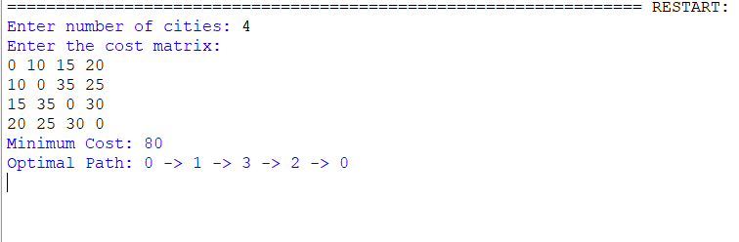
Output:

Result:
Thus, the Python program to implement the Travelling Salesman Problem (TSP) was executed successfully, and the minimum travelling cost along with the optimal path was obtained.

